# **Forecasting Exercise – Replace Payment Provider for Online Website**

Pain as a Service (PaaS) is an online provider of self-service pain. It currently accepts Visa and Mastercard for monthly pain delivered daily to customers internationally.

Recently customers have called the helpdesk saying they can “only” pay by a corporate American Express card, and others saying they “need” to pay by Bitcoin (which an upstart competitor is offering).

Expiring credit cards is an ongoing issue. Auto-bill fails; it’s a hassle for us and the customer to resolve. Proactively telling the customer would likely eliminate these lapses in service and loss of customers.

A new credit card payment provider is offering less fees (3% down to 2%, 1% less per transaction), and the new provider offers better fraud detection which is good because a major increase in overseas customers (20% total and growing) has increased the credit-card fraud levels.

Pain is often purchased near the end of the year where budgets needs to be spent or lost. This means calendar Q4 (October to December) is the largest quarter by far. We don’t do updates to the billing features in Q4.

To ensure credit card data is securely stored, the current checkout system is PCI Compliant. We require an annual audit which has large fines and business exposure if not performed by end of the year. We always leave this to the last minute.

## The exercises

These exercises simulate making decisions using data and intuition. A proposed list of features has been brainstormed and it is your responsibility to answer the two business questions being posed –

* Question 1: Can (& should) we change payment providers before October to December rush season?
* Question 2: What CAN we get by the Q4 (October to December) rush season?

To answer these questions, you will learn through practice –

* How to use historical size data to estimate feature size quickly (reference class forecasting)
* How to forecast size using sampling techniques to obtain a total size for all features
* How to forecast duration using Monte Carlo techniques
* How to prioritize a set of features using various cost of delay techniques
* How to determine what will hit or miss a target date using Monte Carlo forecasting

You will require the following tools

1. Microsoft Excel 2010+
2. These Spreadsheets downloaded from <http://Bit.Ly/ForecastingExercise> (case sensitive, capital F and E)
   1. Story Count Forecaster Exercise spreadsheet (1 - Story Count Forecast for New Credit Card Provider and Fraud Detection.xlsx)
   2. Throughput Forecaster Exercise spreadsheet (2 - Throughput Forecast for New Credit Card Provider and Fraud Detection.xlsx)
   3. Cost of Delay Calculator Exercise spreadsheet (3 - Cost of Delay for New Credit Card Provider and Fraud Detection.xlsx)
   4. Multiple Feature Cut-Line Forecaster Exercise spreadsheet (4 - Multiple Cut Line Forecast for New Credit Card Provider and Fraud Detection.xlsx)

## Proposed features – The Feature and epic Backlog

The product team has defined the following features and worked with the development team to capture the epic level work.

Table 1 - All proposed epics

|  |  |  |  |  |
| --- | --- | --- | --- | --- |
| Feature Grouping | * Value added per Month | Epic ID # | Epic Description | Estimated # Stories (size) |
| Checkout page updates | $0 | 1 | Choose payment card vendor type |  |
|  |  | 2 | Validate card number for types |  |
|  |  | 3 | Capture billing address information |  |
|  |  | 4 | Add security information/logos |  |
|  |  | 5 | Add chargeback fee disclosure wording |  |
| Support Visa and MC card types (new provider) | $1,000 | 6 | Visa and MC Approval workflow |  |
|  |  | 7 | Visa and MC Refund workflow |  |
| Support AMEX cards  (new provider) | $5,000 | 8 | AMEX Approval workflow |  |
|  |  | 9 | AMEX Refund workflow |  |
|  |  | 10 | AMEX additional fee warning |  |
| Support Diners Club card type (new provider) | $500 | 11 | DC Approval workflow |  |
|  |  | 12 | DC Refund workflow |  |
| Support Bitcoin transactions | $1000 (+ competitive advantage) | 13 | Bitcoin Approval workflow |  |
|  |  | 14 | Bitcoin Refund workflow |  |
| PCI Compliance yearly audit | $1,000 fine (+ risk exposure) | 15 | PCI Compliance Audit |  |
|  |  | 16 | PCI Compliance Resolution of Major Issues |  |
| Fraud Detection features | $220 | 17 | US Address fraud detection |  |
|  |  | 18 | Other country Address Fraud Detection |  |
| Card Expiry Reminders | $2,000 | 19 | Three-month before expiry reminder email |  |
|  |  | 20 | Create support desk issue one-month prior |  |

* The additional value estimate will be explained later on, for now, these are the numbers we will assume throughout this exercise.

## Question 1: Can we change payment providers before the start of Q4 (October to December)?

Step 1 is to get an estimate of size. Step 2 is to see if the teams involved have capacity to deliver before October.

## Step 1: Estimating Size – Total Story Count for All Epics

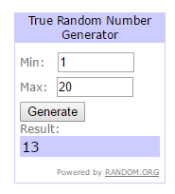We are going to avoid estimating every epic by extrapolating how big all features are by random sampling and estimating only five epics.

**Exercise 1**

1. Select 5 epics at random. Go to the website <https://www.random.org/> and use the tool to generate 5 non-duplicate numbers between 1 to 20, match this to the epic #’s shown in Table 1 - All proposed epics.
2. For the randomly selected 5 epics, estimate the number of stories
   1. Read the epic description and choose a similar epic from those previously completed show below in Figure 1.
   2. Decide where “this randomly selected epic” fits relative to these, and enter the count in Table 1. Ignore the defect count for the moment, we’ll incorporate that later. If there is no prior similar epic, guess intelligently (or throw a six-sided dice, often similar)
3. Enter these samples into the “1 - Story Count Forecast for New Credit Card Provider and Fraud Detection.xlsx” spreadsheet and forecast total story count for 20 epics as shown in my example Figure 2.

Figure 1 - Historical Story Count Data for Reference Class Forecasting

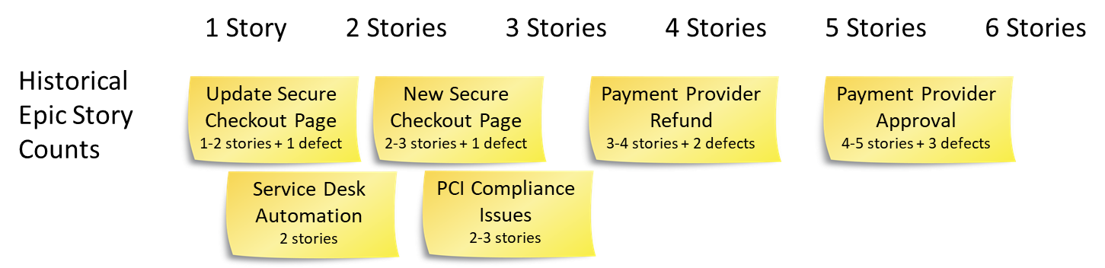

**Example random set of five epics and my thought process**

My randomly chosen epics were epic id’s 17, 1, 7, 2 and 20. Here is the logic used in choosing the story count estimate-

17 – no history, about 4 stories. Proposed simple test address is valid and we have confirmed email

1 – update to current page, about 2 stories

7 – refund, common type, 3 stories

2 – validation logic might need to be learnt, 2 stories

20 – nightly job to check card expiries and if about to expire create service desk issue, 2 stories

Enter these estimates into the Story Count Forecaster (see “1 - Story Count Forecast for New Credit Card Provider and Fraud Detection.xlsx”) and forecast total story counts for 20 epics as shown in Figure 2.

Figure 2 – Example, my 5 estimates in the total story count forecaster spreadsheet

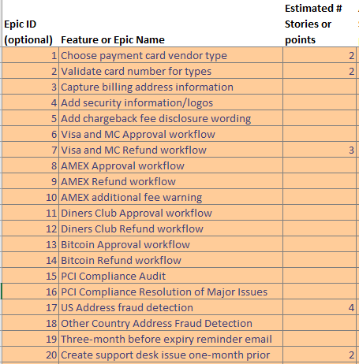 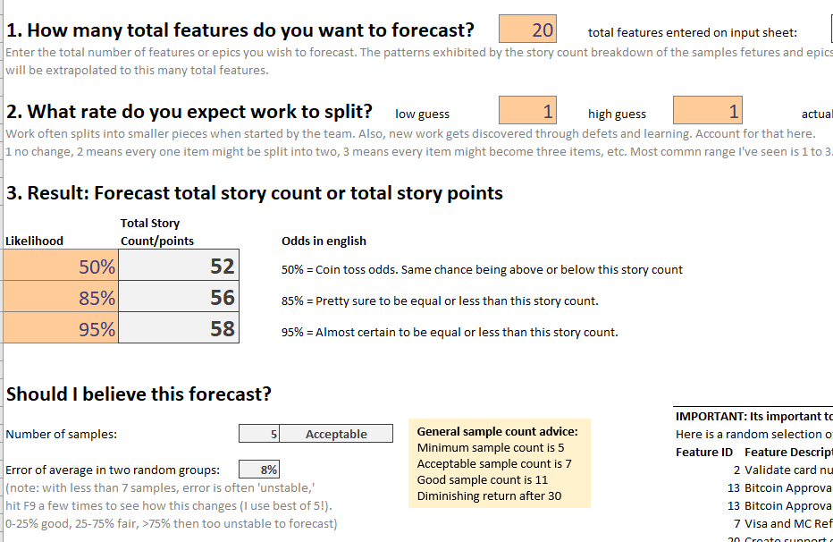

**Exercise 1 Workshop discussion**

Q1. How did reference class forecasting help?

Q2. What might happen if you didn’t choose epics at random?

Q3. Discuss the choice of what likelihood value makes sense for this forecast?

Q4. When might we choose to add a story splitting factor (its default is not to split)?

Q5. What was your average error? Add a couple of more samples and see if it reduces.

## Step 2: Forecast Duration of All Epics

We are going to Monte Carlo forecast using the story count forecast and team historical performance to compute a duration and a likely delivery date.

**Exercise 2**

1. Open the Throughput Forecasting spreadsheet (“2 - Throughput Forecast for New Credit Card Provider and Fraud Detection.xlsx”)
2. Set the input values on the Forecast worksheet
   1. Start Date is 1st July 2017 (if this date has passed, change the year, this is an exercise). Enter it in input 1.
   2. Story Count is the 50% to 95% range (in my case 50 to 58, but use yours discovered in Exercise 1 if you have it). Enter it in input 2.
   3. Split Rate will depend on whether you want to consider defects in your throughput measurement. If YES then you need to account for this by increasing the split rate from 1 to 2 in input 3, else 1 to 1 (no split).
   4. Throughput rate will be assumed 3 to 6 items per week for input 4. This assumes that the team of three dev/test combinations will get at least one item complete each per week, and sometime two each.

These inputs produced the forecast shown in Figure 3 - Initial forecast for all epics based on my example.

Figure 3 - Initial forecast for all epics based on my example performed by the throughput forecasting spreadsheet

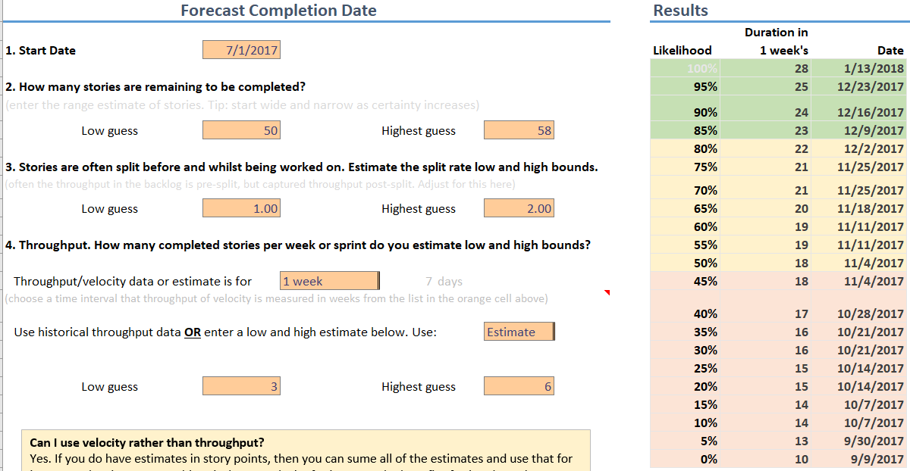

**Exercise 2 Workshop discussion**

Q1. Is it a safe bet that this change can occur by the start of October, the busy period?

Q2. When would you need to START this project to be happy to have delivered by 1st October?

Q3. What would the throughput rate need to be to be happy to have delivered by 1st October?

Q4. Was the split rate of 1 to 2 appropriate? (hint: see defect rates in Figure 1)

Q5. How might a better throughput range estimate be created?

## Question 2: What CAN we get by the Q4 (October to December) rush season?

This is a multiple step question –

1. What is an appropriate prioritization of these features
2. How far through this list do we reach, and does that still make sense to try?

## Step 1 – determining priority based on Cost of Delay

Here are some economic facts to help make decisions –

* Currently there are 1000 subscribers who pay $100 per month for pain (total rev $100,000/m).
* Visa and Mastercard currently make up 100% of transactions.
* Lack of American Express support is estimated to lose 50 to 100 subscribers per month.
* Lack of Diners Club support is estimated to lose 1 to 5 subscribers per month (but decreasing).
* A competitor has launched accepting Bitcoin support. Estimated loss of 10 transactions a month.
* 2% of subscribers who encounter expiring credit cards never return to renew (lost to competitor).
* PCI Compliance (credit card security) is audited yearly with fines of $1000 per month if missed (starting January). Penalty of data breach if this isn’t performed are catastrophic (~20% total revenue risk per month).
* Fraud is an issue. Most fraud comes from overseas customers which is 20% of your business. 1% of those charges are disputed and refund and penalized an additional 10% fee (math: 20% of 1000 = 200 overseas subs. 1% of 200 = 2 chargebacks. 2 times $100 + $10 = $220).

**Exercise 3**

Perform a rapid qualitative cost of delay assessment and see if the order makes sense -

1. Open the “3 - Cost of Delay for New Credit Card Provider and Fraud Detection.xlsx” spreadsheet
2. Select the “WSJF Prioritization (simple)” worksheet
3. Work as a group on the qualitative Cost of Delay value assumptions and decide where each feature ranks from 1 – Low to 5 – Critical. Look to separate value relative to each feature, don’t get too hung up on particulars. I’ve already entered the size estimate for you based on the Reference Class Forecasts we did earlier, and also some example rationales to start with based on the facts above..

Hint: Table 1 - All proposed epics has some value estimates that you might refer to when making your own value estimate.

Figure - Choose a relative value from the drop-down for each feature. Explain your reasoning in the Rationale column

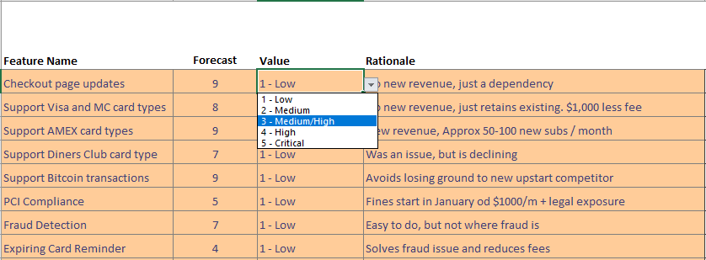

**Exercise 4**

From the facts, work as a group to decide a monthly impact of each feature. I’ve given you the total duration for each feature based on rough estimates using Figure 1. Your job is to rank order based on cost of delay using the Weighted Shortest Job First technique (divide value by size and do biggest first).

Table 2 - Cost of Delay Calculations (I’ve given you size, it was estimated using the same way we did in Exercise 1)

|  |  |  |  |  |
| --- | --- | --- | --- | --- |
| Feature Name | Size  Est. # stories | * Value Increase  $/month | Compute Value ÷ Size  (WSJF) | Rationale  (explain how you computed value & why this order is/isn’t optimal) |
| Checkout page updates | 9 |  |  |  |
| Support Visa and MC card types | 8 |  |  |  |
| Support AMEX card types | 9 |  |  |  |
| Support Diners Club card type | 7 |  |  |  |
| Support Bitcoin transactions | 9 |  |  |  |
| PCI Compliance | 5 |  |  |  |
| Fraud Detection | 7 |  |  |  |
| Expiring Card Reminder | 4 |  |  |  |

* Table 1 has pre-computes $/month added value estimates. You can use them or estimate your own based on your analysis of the assumptions.

**Exercise 4 Workshop discussion**

Q1. Are there any dependencies in this list?

Q2. Do some features HAVE to be done earlier for one reason or another?

Q3. If we ignored size, would you have achieved a similar order? Discuss the ramifications.

**Exercise 5**

Crate a quantitative cost of delay ranking that accounts for value, size and dependencies between items using the Cost of Delay Calculator spreadsheet.

1. Open the “3 - Cost of Delay for New Credit Card Provider and Fraud Detection.xlsx” spreadsheet.
2. Select the “WSJF Prioritization (intermediate)” worksheet
3. Work as a group on the quantitative Cost of Delay (intermediate) values. Write down the rationale for each dollar value and discuss.

**Exercise 5 Workshop Discussion**

Q1. What would you do if it was hard to put a dollar value on things?

Q2. Feature 1 has no value by itself, but second highest with children. Does this occur often?

Q3. How else could the dependencies be handled? For example, is all feature 1 needed before feature 2-5?

Figure 5 - Here are my assumptions around value, and the total story count based on estimating size. Do you agree?

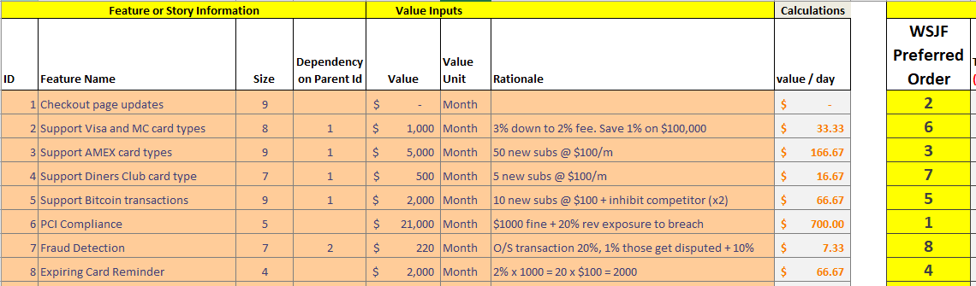

## Step 2 – Forecast what could be achieved by the target date

This step will work out how far through the feature backlog we might safely achieve by the last calendar quarter.

**Exercise 6**

See how much can be achieved in the “optimal” order we just calculated

1. Open the “4 - Multiple Cut Line Forecast for New Credit Card Provider and Fraud Detection.xlsx” spreadsheet.
2. Select the “Forecast” worksheet
3. Enter the following forecast input values
   1. Start date is 1st July 2017 (Use your local date format e.g. 7/1/2017 in the US)
   2. Target date is 1st October 2017 (again in your local date format)
   3. Likelihood: Leave this at 85%
   4. Story split rate. Leave room for some defects and new ideas. Low guess: 1 Highest and guess: 2
   5. Throughput estimates. Let’s stick with our assumption with three devs. Low of one story each, 3 total. And a high of two stories each of 6. Make low guess: 3 and Highest guess 6.
4. Confirm that the forecast results are working. Observe the forecast completion dates are sequentially getting later.
5. Set the start order to the order matching your results in Exercise 5 (or use mine if you had trouble). You should see a result similar to that in Figure 6.

Figure 6 - Example forecast results. Green ticks = made it, Red crosses = missed.

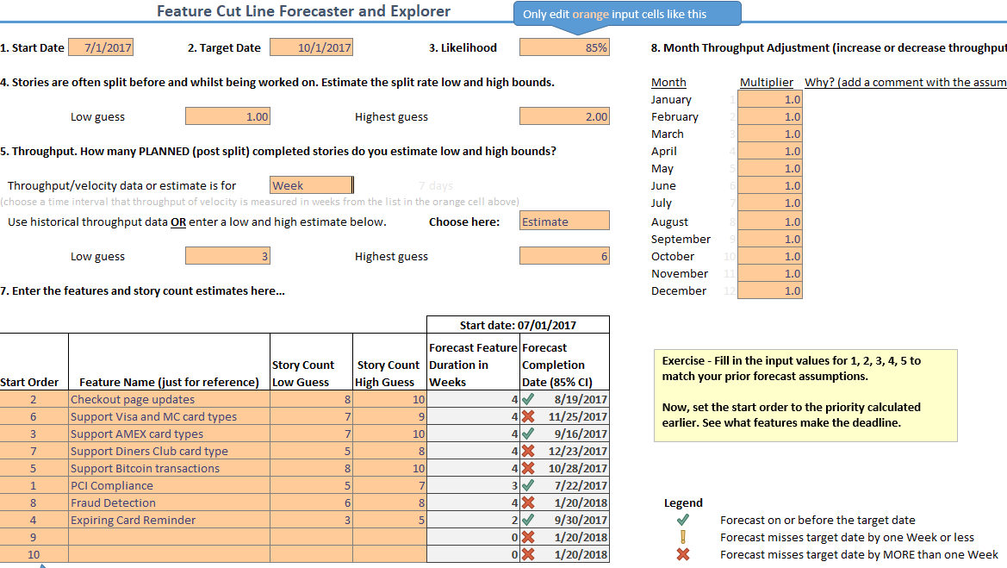

**Exercise 6 Workshop Discussion**

Q1. Discuss the results? What was the last safe feature that made the target date?

Q2. Double the delivery rate. Simulate by changing all input 8 multiplier values to 2.0 (going twice as fast). Does everything make it now?

Q3. If you were to increase team capacity, how might you achieve it?

Figure 7 - Here is my complete cut line forecast showing all of the inputs used.

